Image | 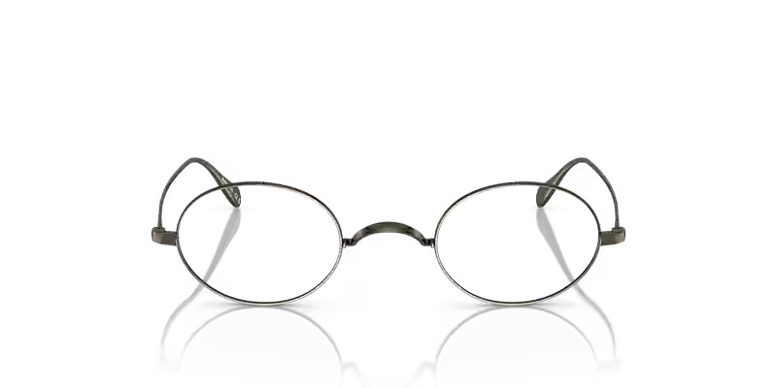
Brand | DIOR
Model Name | CALIDOR
Price | RS 1449
PRODUCT DETAILS

